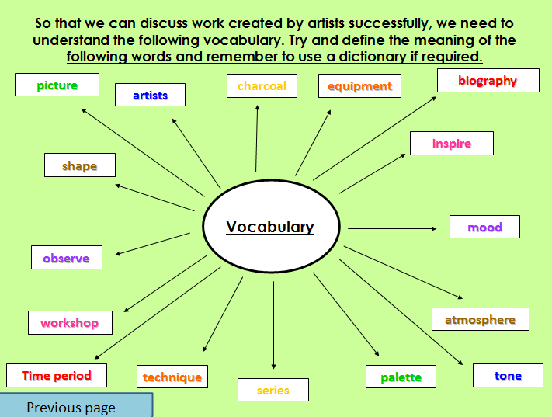
Workers and the workhouse during Victorian Times.
Unit 1 – Vocabulary

By using a dictionary can you find the definition for each word?

picture:
artists:
charcoal:
equipment:
biography
inspire:
mood:
atmosphere:
tone:
palette:
series:
technique:
time period:
workshop :
observe:
shape:

